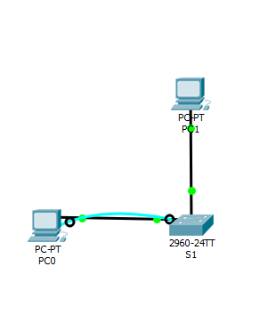

PC1

FastEthernet0 Connection:(default port)

Link-local IPv6 Address.........: FE80::201:C9FF:FE18:62C9

IP Address......................: 192.168.3.1

Subnet Mask.....................: 255.255.255.0

Default Gateway.................: 0.0.0.0

PC2

FastEthernet0 Connection:(default port)

Link-local IPv6 Address.........: FE80::250:FFF:FE1E:2D8D

IP Address......................: 192.168.3.2

Subnet Mask.....................: 255.255.255.0

Default Gateway.................: 0.0.0.0

S1

C:\>ping 192.168.3.254

Pinging 192.168.3.254 with 32 bytes of data:

Request timed out.

Reply from 192.168.3.254: bytes=32 time<1ms TTL=255

Reply from 192.168.3.254: bytes=32 time<1ms TTL=255

Reply from 192.168.3.254: bytes=32 time<1ms TTL=255

